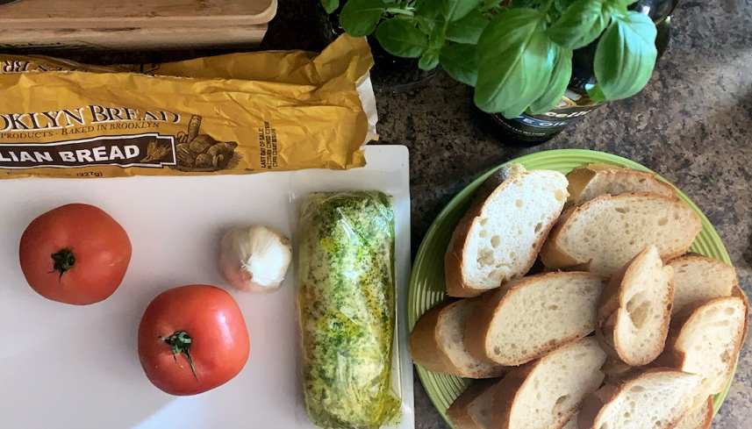
Bruschetta Fior Di Latte

Serves: 3

Ingredients:
- Fresh Italian bread
- Roma or sweet tomatoes
- Garlic cloves
- Fresh mozzarella (Miyoko’s- vegan option)
- Pesto (for fresh pesto blend; basil, pine nuts, garlic, EVOO, and salt)
- Fresh basil
- Salt
- Extra virgin olive oil
- Balsamic glaze (optional)

Directions
- Start by roasting your garlic. Heat your oven (can also be done in a toaster oven) to 400 degrees F. Prepare foil, large enough to wrap your garlic. Peel away any extra white skin, leaving enough to hold the head of garlic together. Cut a ¼ inch from the top of the cloves so the individual cloves are exposed. Place garlic on the foil, cut side up and drizzle olive oil. Close foil and place in the oven. Roast until the cloves inside are light brown and soft, roughly 40 minutes.
- While the garlic is roasting, prepare your pesto mozzarella. Whether you decided to make or purchase your pesto, marinate your mozzarella at this point.
- Slice your Italian Bread diagonally.
- Cut the tomatoes to your liking. (round slice or diced)
- Grill or toast your bread for a nice crunch
- Take your roasted garlic and mix with EVOO. Mash it up, making a spreadable garlic oil paste.
- Brush your garlic oil onto your toasted Italian bread. Assemble with pesto mozzarella, tomato and sprinkle with a bit of salt. Smack your fresh basil to extract the oils and place on top. Finish with a light drizzle of balsamic glaze and enjoy!

